**Topic: Version Control Soft wares GIT & Git Hub Introduction:**

**Q1. What are Version Control Software and Why We need it?**

Ans:

* A project development will happen with several team members
* All project development team members may not be available in same location.
* If development is happening from multiple locations then how to integrate code ?

Ex: Hyd team, Chennai team, Pune team etc...

**Drawbacks:**

1. Code Integration is the first problem
2. Monitored Access is the second problem

To avoid these 2 problems, Version Control Software came into picture

If we use version control software in our project they will take care of **code integration and code monitoring.**

-> Version Control soft wares are also called as **Software Configuration Management software.**

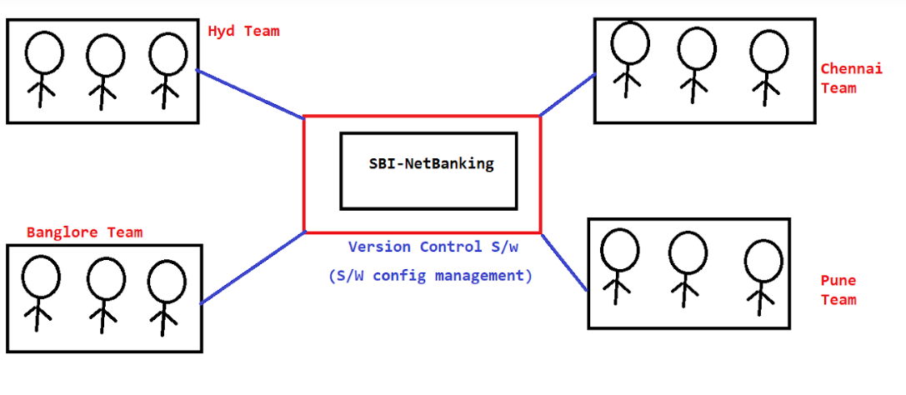

**Q2. What are the version control software’s available?**

Ans:

* IBM Clear case
* SVN (Subversion)
* GIT HUB
* BitBucket etc.....

**Note:** GIT and BitBucket having lot of demand in market. Some legacy projects are still using SVN.

**Version Control Terminology**

* **Repository** : It is the place where we will store our source code
* **Repository ID / Commit id**: When we add new file/modified existing file then one commit id will be generated. Commit id will be used for tracing purpose.
* **Clone**: Taking the entire project from repository to local system.
* **Commit / Check-in :** To push changes to repository
* **Update/Pull:** Taking latest changes committed by team members.
* **Revert** : Removing committed changes from Repository
* **logs** : Checking commit history

**Working with GIT (Environment setup**

1. Create Account in (github.com)
2. Install GIT cient software
   1. (<https://git-scm.com/downloads>)
3. For every project one GIT repository will be created by GIT Admin in GIT HUB.
4. GIT Admin will provide repository access for all project team members
5. Being a team member we will install GIT client software in our machine and we will perform GIT operations in Project Repository with client software.

**Note**:

1. Every Team member will have a GIT account (Once you join in project, they will create GIT account for you and they will share credentials with you)
2. You should not share your GIT credentials with anyone (It should be confidential).
3. Installing GIT client is not mandatory. We can perform GIT operations from IDE (Eclipse, STS and IntelliJ) also.

**GIT Repositories**

1. For project we will create one repository in Git Hub
2. Git Hub will maintain our repositories in centralized location
3. We will use git client software to communicate with git hub repository
4. We can use several clients to communicate with Git Hub repository

1) Git Bash

2) Git Gui

3) Tortoise Git

4) Source Tree

5) IDE (Eclipse, STS, IntelliJ)

**Create Repository in Git Hub**

1. We can create 2 types of repositories in Git Hub

1) Public Repository

-> Anybody can see but we choose who can commit

2) Private Repository

-> We will decide who can see and commit

2. Once repository got created, it will generate repo URL for our repository like below

**https://github.com/USERNAME/ApplicatioName.git**

**Q. Who will create Git Repository?**

Ans:

1. Project team member will send a request to Git admin team through email for creating repository then they will create repository and they will share repository URL.
2. Git admin will share this repo url with all team members.
3. After getting this URL team members will perform operations using Git clients.
4. Once we got repository url, we need to perform git operations using git client softwares.

*Sample Mail format*

From : chanti@abc.com

to : gitadmin@abc.com

cc : ourmanager-email-id

Subject: Git repository creation request

Body :

Hi Team,

Greetings for the day..!!

We are starting new project from tomorrow(20-Aug-2020) so please create GIT repository for the same with below details

Repository Name : SBI-App

@Manager-Name : Please approve this request.

Thanks,

Chanti.

**Working with GIT Bash**

* Download and install Git client software
* After installing git client, right click on Mouse and select Git Bash Here -> It will open Git Bash cmd

**Git Bash Commands**

* 1. git help : It displays commonly used git commands
  2. git help <cmdname> : Open documentation of the command
  3. git init : To initialize our directory as empty git repository

**Configuring Uname and Email in Git Bash**

git config --global user.name "urname"

git config --global user.email "urmailid"

* 1. git add <file/folder> : To add files/folders to staging are

**Note**: The files which are added to staging area they are eligible for commit

* 1. git status : To display staged & un-staged files
  2. git commit -m <msg> : To commit changes to git local repository
  3. git remote add <repo-url> : To add repository url to local directory
  4. git push -u origin master : To push changes from local repo to central repo

**Note**:

1. If we are pushing changes for first time it will ask our git account credentials (We have to provide valid credentials)
2. Git credentials will be stored in windows credentials.
3. If we want to work with multiple git accounts we have to remove saved git credentials from Windlows Credentials

Control Panel -> Credential Manager -> Windows Credentials -> Remove Git